# Ngăn không wake up khi máy tính đang ở chế độ sleep

Gõ lệnh: powercfg -devicequery wake_armed

It will show list of devices which cause computer wake up when sleepping

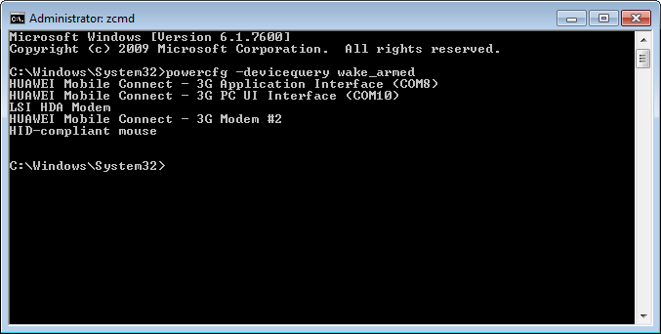

***Method 1:***

Use this command for all devices in this list:

**powercfg -devicedisablewake "Device Name"**

powercfg -devicedisablewake "HUAWEI Mobile Connect - 3G Modem"

powercfg -devicedisablewake "HUAWEI Mobile Connect - 3G Application Interface (COM6)"

powercfg -devicedisablewake "HUAWEI Mobile Connect - 3G PC UI Interface (COM7)"

powercfg -devicedisablewake "LSI HDA Modem"

powercfg -devicedisablewake "HID-compliant mouse"

powercfg -devicedisablewake "HUAWEI Mobile Connect - 3G Application Interface (COM11)"

powercfg -devicedisablewake "HUAWEI Mobile Connect - 3G PC UI Interface (COM10)"

powercfg -devicedisablewake "HID-compliant mouse"

powercfg -devicedisablewake "HUAWEI Mobile Connect - 3G Modem #2"

***Method 2:***

Go to Device Manager, choose devices in this list, after that choose Propeties -> Power Management -> unchecked Allow this device to wake the computer

